


Recommended Riparian Corridor Layer for use in Land Use Planning
July 2024

Introduction
Functioning riparian (river bank) corridors can help increase the resilience of a place to the impacts of climate change and help address the nature crisis, providing environmental benefits, and a wide range of public services. These areas are also an important element of blue green infrastructure (BGI) and nature networks (NN).
A GIS layer has been created which indicates the minimum space needed along rivers (i.e. riparian corridor width scaled to river width) to give rivers space to adapt to changes in flood frequency and magnitude and to provide a range of benefits which are described in section 2. It is hoped that this source of evidence will be of use to land use planners in relation to climate adaptation and informing BGI and NN mapping required from National Planning Framework 4 (NPF4) for local development plans (LDPs), as well as for site specific considerations regarding allocations and development management applications.
It is noted that where there is opportunity for river restoration, the width of the riparian corridor may be considerably greater than the minimum. Buffer widths in agricultural settings will be determined by site specific considerations, and at onshore windfarm sites buffers will accord with the industry adopted standard.

The purpose of this supporting note is to provide:
- an overview of the benefits of healthy functioning riparian corridors,
- what a functional riparian corridor looks like,
- an explanation of what the recommended riparian corridor layer is and how it could be utilised,
- Appendix 1 provides details of the literature review and references.

Social, Economic & Environmental Benefits of River Corridors
Figure 1 below provides a summary of the range of benefits of healthy functioning riparian corridors with examples of these benefits provided in section 2.1 overleaf.

Figure 1: Benefits provided by healthy riparian corridors.

2.1 Examples of Benefits of Riparian Corridors

Climate Adaptation
Giving rivers more space to adjust is becoming increasingly important as rivers adapt to the changes in flood frequency and magnitude brought about by climate change. To accommodate more frequent floods, rivers will erode their banks to increase their channel size, thereby increase their capacity so they can convey larger volumes of water.

Water Quality
Appropriately sized riparian corridors can intercept overland flow, filter out sediments and reduce pollution load. They also provide a margin between the river and activities which may give rise to pollution directly e.g. pesticide or fertiliser application.
Wooded riparian corridors stabilise banks, reducing fine sediment input and erosion risks.

Habitats and Wildlife
Healthy, functioning riparian corridors provide greater habitat area and connectivity as well increased protection of niche habitats.
Riparian vegetation provides shade to protect against river overheating in the summer, which is important to maintain species life cycles and delivers important nutrients through leaf litter and debris input.

Flooding
Undeveloped riparian corridors mean buildings and infrastructure are set-back from the river, reducing the risk of them flooding.
A reduction in flooding can occur because of increased infiltration, changes to surface roughness and increasing space for water storage.

Air Quality
Wooded riparian buffers remove pollutants from the air and provide effective noise buffers. NHS data showed removing 1 µg/m3 of fine particulate air pollution could prevent around 50,900 cases of coronary heart disease and 16,500 strokes, over an 18-year period.
Carbon dioxide is absorbed from the air by vegetation which aids climate change mitigation. Undeveloped, vegetated riparian corridors allow build-up of organic matter in the soil with carbon stored in vegetation and soil.

Placemaking, Community & Amenity Opportunities
Greater aesthetic value provides people with a greater sense of place as well as areas for recreation activities such as dog walking, running, and reading which can be beneficial for health and wellbeing.
Riparian areas provide outdoor education opportunities, which helps children learn more and retain concepts longer.

Economic Benefits
Green space has been linked to increases in property value. Data from the Office of Statistics found that the price of detached houses & flats within 100 m of green space increased by 1.9% and 0.6%, respectively.
Giving rivers space has future benefits of reducing erosion risks to planned infrastructure and other built development; and reduced on-going maintenance costs.

2.2 Evidence of the Benefits of Riparian Corridors
Reviews of the scientific literature and evidence supporting the multiple benefits of riparian corridors can be found in the reports referenced in Appendix 1.

A Healthy Functioning Riparian Corridor
Figure 2 shows the differences between a functioning, healthy (good condition) riparian corridor and a non-functioning riparian corridor and highlights the importance of leaving these margins undeveloped, and of establishing multilayer vegetation if the benefits are to be achieved and maximised. The photographs in figure 3 are examples of functioning riparian corridors in non-rural settings in Scotland.
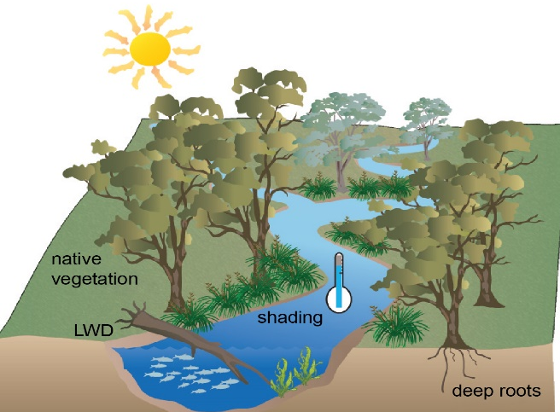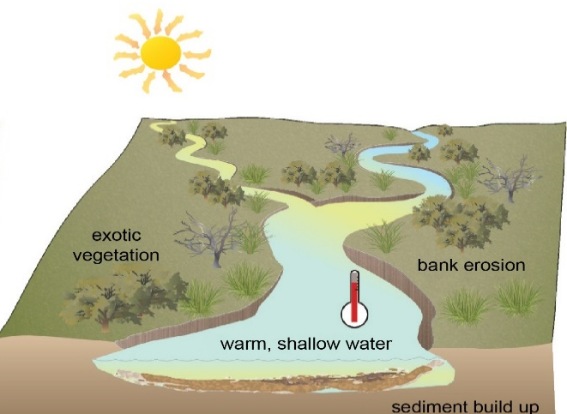
Functioning Riparian Corridor
- Banks characterised by native trees, grasses and woody scrub creating well-structured and stable banks which reduce erosion and fine sediment input.
- Organic material in the channel such leaf litter and large woody debris providing greater habitat complexity and carbon storage.
- Clean running water due to greater filtration of nutrients and other contaminates.
- Cool water, reduced water scarcity issues and diverse aquatic life due to greater ground water recharge and the shade provided by the presence of native trees.
- No or only green bank protection measures due to native trees stabilising the bank.
Non-Functioning Riparian Corridor
- Banks characterised by grasses and invasive annual plant species with eroding banks due to instability.
- Dirty polluted water and a river bed smothered with fine sediments due poor infiltration and rapid run-off rates.
- A wide homogenous featureless channel due to a lack of bankside trees and large wood input into the river.
- Rivers with poor aquatic species diversity due to high water temperatures, lack of habitat complexity and poor water quality.
- Hard bank protection measures due to easily erodible banks.
Figure 2: Differences between functioning and non-functioning Riparian corridors. Images modified from NSW River Condition Index
Figure 3: Examples of healthy, functioning corridors with multi-layer vegetation in non-rural settings:
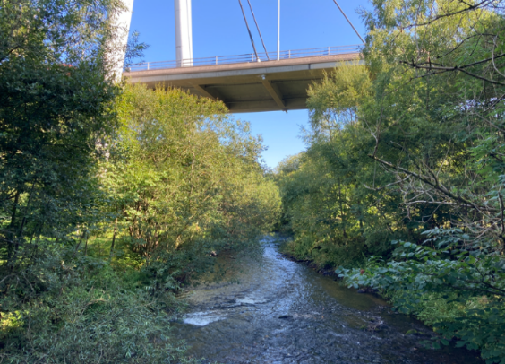
Above is a section of the River Leven in Glenrothes
Below is The Gala Water through Torwoodlea Golf Course near Galashiels
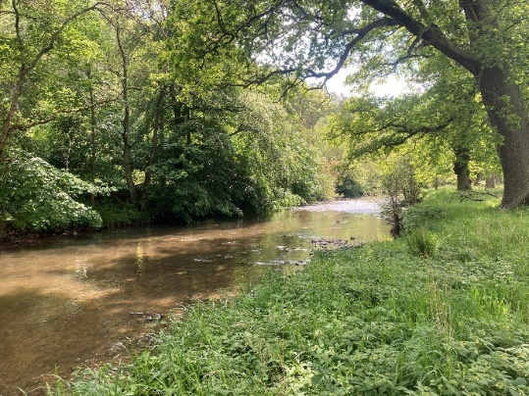

Recommended Riparian Corridor Width Layer for Scottish Rivers
The GIS layer shows minimum proposed riparian corridor widths scaled to the width of the watercourse, which if left undeveloped increase climate resilience by giving rivers space to adapt to changes in flood frequency and magnitude and provide a wide range of benefits. It is available to download from Environmental data | Scottish Environment Protection Agency (SEPA) and is called the ‘Recommended Riparian Corridor’ layer.
This layer should be considered alongside the ‘Geomorphic Risk Buffer’ Layer (available from the same webpage), which maps locations where increased geomorphic adjustment is predicted to occur. This would identify areas where a wider riparian corridor would be beneficial, due to an increased potential risk of future bank erosion. In addition, it should be noted that erosion tends to be greater around the outside of meander bends. Therefore, increasing the riparian corridor width at these locations, where possible would be recommended.

Applications for land use planning

Development Planning
The layer is a source of evidence that is relevant for required Nature Network (NN) and Blue Green Infrastructure (BGI) mapping and to inform proposed allocations to help delivery of LDP instructions of several policies in NPF4:
Policy 2 Climate mitigation and adaptation – consideration and incorporation of riparian corridors into allocations supports adaptation to climate change by giving rivers room to adjust to changes in flood frequency and magnitude brought about by climate change.
Policies 3 Biodiversity, 4 Natural places and 6 Forestry, woodland and trees – identification of the river network with riparian corridors as an integral asset in nature networks and identification of opportunities for restoration of degraded or creation of new habitats accords with protecting and restoring biodiversity, ecosystems, natural processes, and expansion of woodland and trees to provide multiple benefits.
Policies 20 Blue and green infrastructure and 22 Flood risk and water management – the utilisation of the layer in BGI mapping would help address the requirement for identification and protection of BGI assets and infrastructure and identification of opportunities for improvement to the water environment.

Development Management
The layer is relevant to inform the layout of:
- Proposed developments on previously undeveloped land. Safeguarding the riparian corridor from built development and individual householder ownership provides space for the river to function naturally and adjust to climate change and ensures the wide range of environmental, social, and economic benefits provided are maintained.
- When redevelopment/ regeneration occurs, there is potential to use this layer to highlight areas where the river would benefit from more space.
- New place-making or habitat enhancement opportunities proposed near the river environment such as de-culverting water courses through a park.
It should be noted that it is not proposed that any infrastructure or buildings currently within the recommended riparian corridor width be removed unless it can be achieved as part of a re-development opportunity. NPF4 determines what new development may be acceptable within the area at risk of flooding. Areas at risk of flooding from rivers will overlap with riparian corridors to varying degrees at different sites.

Scaling Riparian Corridor Width to the Watercourse
The recommended riparian corridor width has been scaled to channel width, to reduce land take whilst still ensuring the benefits of the riparian corridor are realised. The recommended minimum corridor widths for each bank are provided in Table 1. Figure 4 provides an example of what the riparian corridor width layers looks like when viewed within GIS.

Table 1: Recommended riparian corridor width on each side of the channel. This is measured from the bank top, perpendicular to the watercourse.
Channel width | Recommended corridor width on each channel bank
< 2 m | 10 m
2 to 15 m | 15 m
> 15 m | 30 m

A summary of the findings of the literature review undertaken to inform development of the layer are provided in Appendix 1. Details of how the corridor widths were derived can be found in the separate ‘Technical Note on the creation of a recommended riparian corridor GIS layer for Scotland’ from RBMP information sources | Scottish Environment Protection Agency (SEPA).
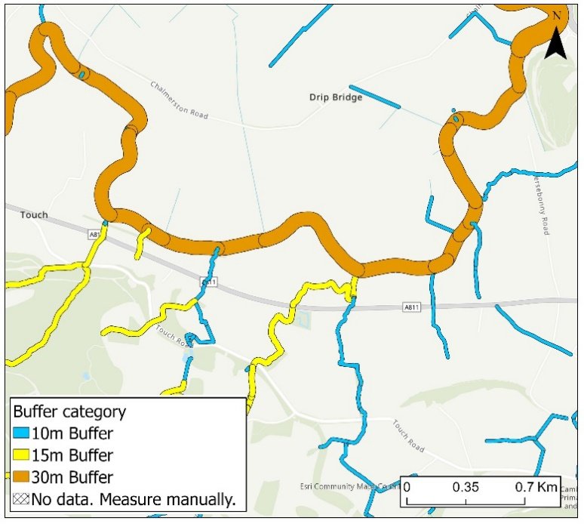
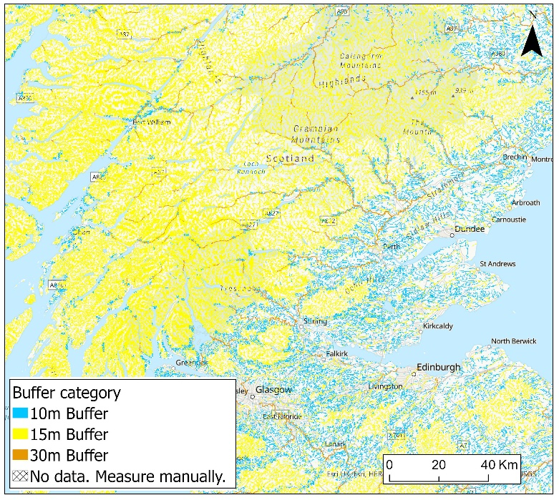
Figure 4: The recommended riparian corridor layer as shown at the coarser national scale and a more local scale. This illustrates the different riparian corridor widths required for streams of different sizes.

Appendix 1

River Corridor Width in the Literature
The aim of this work was to establish what a minimum riparian corridor width would be to provide a range of environmental and social services and aims to strike a balance between the width required to provide these services and the demand for built development.
Figure 5 shows the minimum and optimal riparian corridor width on each channel bank for various parameters based on a large volume of literature researching riparian buffer widths. This data indicates that a range of multiple benefits can be achieved with a minimum width of 15 m on each bank, but that 30 m would be more optimal.
The benefits of a riparian corridor are also found to be commonly scaled to a multiple of channel width. Extensive research suggests that a riparian corridor width of five times channel width is optimal for sustaining natural river functioning, hence the use of width-based categories for designating the ideal width of riparian margins. A summary of recommended riparian corridor widths applied in different areas of the globe is provided below figure 5.

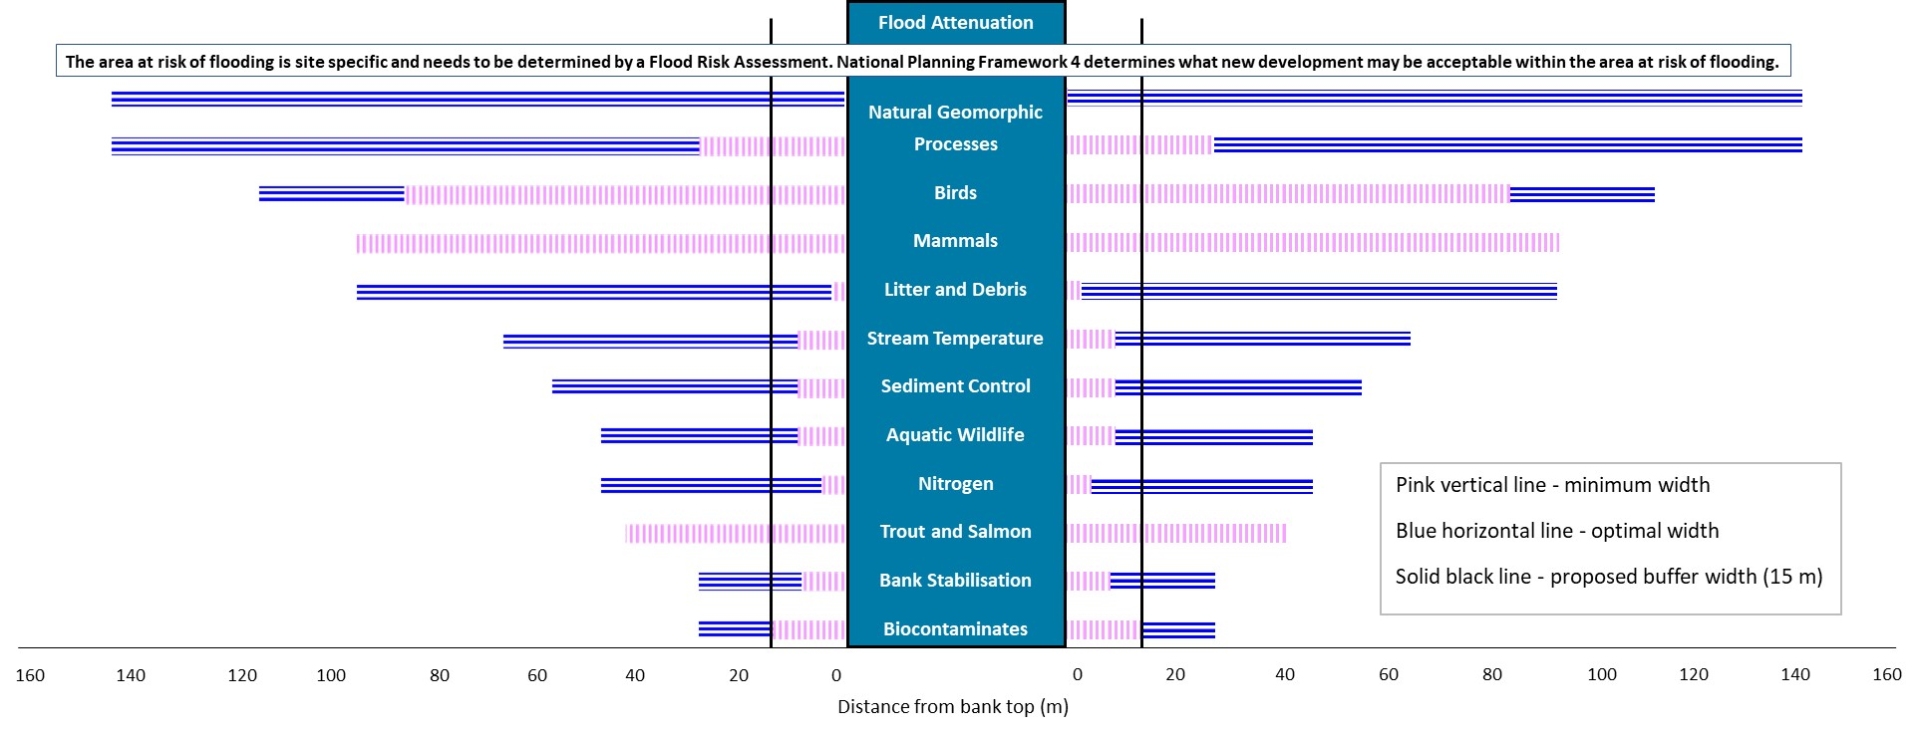

Figure 5: Minimum and optimal riparian corridor widths to provide different environmental services and benefits from literature.

Overview of literature on riparian corridor widths across the globe
This section outlines the recommended riparian corridor width along both bank for different countries and states.
- Vermont (USA) – 15 to 30 m riparian buffer based on an evaluation of site attributes such as erosion risk, floodplain requirements, level of water quality protection required and presence of sensitive species.
- Minnesota (USA) – minimum buffer width of 15.2 m along lakes, rivers, and streams and 5 m along ditches.
- Georgia (USA) – minimum of 7.5 m buffer along creeks, streams, rivers, saltwater marshes, lakes and ponds, and 15 m along trout streams. However, 30 m buffer is often required along larger rivers and rivers which feed water supply reservoirs.
- Australia – A permit is required for any works within 100 m in Queensland and 30 m in West Australia, Victoria and Tasmania of the bank top.
- Germany – 5 m wide corridors are required if slopes < 10%. If slopes > 10% then 10 m wide corridors are required.
- Spain – rivers are public domains with space for morphology based on functional flows and proposed initial corridor widths of 30 m to maximise environmental benefits.
- New Zealand - a minimum corridor width of 10 m on either side of a stream is recommended to ensure the development of sustainable indigenous vegetation on smaller and urban streams. However, this is often increased in steep rural areas where nutrient filtration is required for maintaining good water quality and bank stability. On larger rivers a riparian corridor width of 20 m is recommended.

Recommendations
From this research it is suggested that a minimum riparian corridor width of 10 to 30 m from bank top along both banks of all watercourses based on their channel width.
In areas where modelling shows a greater risk of erosion and channel adjustment (e.g. as indicated by the ‘geomorphic risk buffer' layer) the riparian corridor width should be adjusted accordingly.

References
Beacon Environmental Ltd. 2012. ‘Ecological Buffer Guideline Review.’ Credit Valley Conservation.
Bentrup, G. 2008. Conservation buffers: design guidelines for buffers, corridors, and greenways. Gen. Tech. Rep. SRS-109. Asheville, NC: Department of Agriculture, Forest Service, Southern Research Station. 110 p.
Burgess-Gamble, L, Ngai, R, Wilkinson, M, Nisbet, T, Pontee, N, Harvey, R Kipling, K, Addy, S, Rose, S, Maslen, S, Jay, H, Nicholson, A, Page, T, Jonczyk, J & Quinn, P. 2018. Working with Natural Processes – Evidence Directory, SC150005, Environment Agency.
Broadmeadow, S. and Nisbet, T.R., 2004. The effects of riparian forest management on the freshwater environment: a literature review of best management practice. Hydrology and Earth System Sciences, 8(3), pp.286-305.
Ellis, Janet H. "Scientific Recommendations on the Size of Stream Vegetated Buffers Needed to Protect Wildlife and Wildlife Habitat, Part Three, The Need for Stream Vegetated Buffers: What Does the Science Say." Report to Montana Department of Environmental Quality, EPA/DEQ Wetland Development Grant. Montana Audubon, Helena, MT (2008).
Hansen, B., Reich. P., Lake, S., Cavagnaro, T. 2010. ‘Minimum Width requirements for riparian zones to protect flowing waters and to conserve biodiversity: a review and recommendations with application to State of Victoria.’ Monash University prepared for e Office of Water, Department of Sustainability and Environment
Hawes, E. and Smith, M., 2005. Riparian buffer zones: Functions and recommended widths. Eightmile River Wild and Scenic Study Committee, 15, p.2005.
Health matters: air pollution (2018).
Lind, L., Hasselquist, E.M. and Laudon, H., 2019. Towards ecologically functional riparian zones: A meta-analysis to develop guidelines for protecting ecosystem functions and biodiversity in agricultural landscapes. Journal of environmental management, 249, p.109391.
Meyer, J. L., Jones, K. L., Poole, G. C., Jackson, C. R., Kundell, J. E., Rivenbark, B. L., Kramer, E. L. and Bumbeck, W. 2005. ‘Implications of Changes in Riparian Buffer Protection for Georgia’s Trout Streams.’ University of Georgia for Georgia Environmental Protection Division, Department of Natural Resources. Athens, Georgia.
Minnesota Buffer Law | MN Board of Water, Soil Resources (no date). https://bwsr.state.mn.us/minnesota-buffer-law.
Nelson, A.D., Collins, V.D., Payne, J.S. and Abbe, T.B., 2024. Proactive river corridor definition: Recommendations for a process‐based width optimization approach illustrated in the context of the coastal Pacific Northwest. Wiley Interdisciplinary Reviews: Water, p.e1711.
Ogilvy, T, Melville, N, & Martinez, R. 2022. Riverwoods for Scotland Report on Scientific Evidence. Riverwoods Steering Group.
Parkyn, S., Shaw, W., and Eades, P. 2000. ‘Review of information on riparian buffer widths necessary to support sustainable vegetation and meet aquatic functions.’ National Institute of Water & Atmospheric Research Ltd. Auckland.
Price, P., Lovett, S. & Lovett, J. 2004, ‘Managing riparian widths’, Fact Sheet 13, Land & Water Australia, Canberra.
Qiu, Z., Prato, T. and Boehrn, G., 2006. Economic Valuation Of Riparian Buffer And Open Space In A Suburban Watershed1. JAWRA Journal of the American Water Resources Association, 42(6), pp.1583-1596.
Urbanič, G., Politti, E., Rodríguez-González, P.M., Payne, R., Schook, D., Alves, M.H., Anđelković, A., Bruno, D., Chilikova-Lubomirova, M., Di Lonardo, S. and Egozi, R., 2022. Riparian Zones—From Policy Neglected to Policy Integrated. Frontiers in Environmental Science, 10, p.868527.
Team, N.C. (2019) Urban green spaces raise nearby house prices by an average of £2,500 - Office for National Statistics.
Vermont Agency of Natural Resources. 2005. Guidance for Agency Act 250 and Section 248 Comments Regarding Riparian Buffer.
Wenger, S. 1999. A Review of The Scientific Literature on Riparian Buffer Width, Extent and Vegetation. Office of Public Service & Outreach Institute of Ecology University of Georgia.
Young, N., Deardorff, L.G., and Hazelwood, B. 2016. Economic Value of Riparian Buffers. American Rivers. Washington.

For information on accessing this document in an alternative format or language, please contact SEPA by emailing equalities@sepa.org.uk

If you are a user of British Sign Language (BSL), the Contact Scotland BSL service gives you access to an online interpreter, enabling you to communicate with us using sign language. contactscotland-bsl.org

